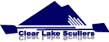
Clear Lake Scullers
LEARN TO ROW DAYS
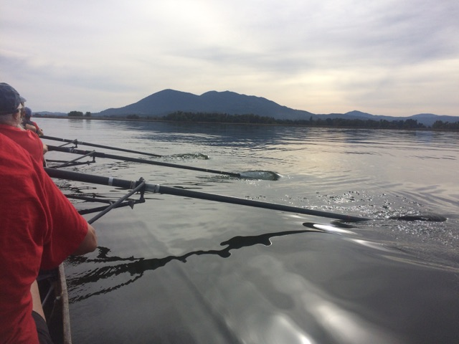

Saturdays June 30th and July 7
Anytime between 8:00 am to Noon

Clear Lake Scullers boat yard,
Natural High School, Main St. LAKEPORT

Learn to sweep row, scull, or paddle kayaks and canoes, or take a refresher at Clear Lake Scullers annual open house and Learn to Row Days. Residents and visitors of all ages are welcome. CLS offers summer classes for adults and students for rowing, paddling, and water safety.

Contact: Mike Sullivan www.clearlakescullers.org sulsness@yahoo.com 707-349-9779

