Adult Rowing Camp, Summer 2014
Clear Lake Scullers is a community based rowing club offering instruction and access to rowing, paddling, canoeing, kayaking and sailing equipment. Membership is open to the public with year round programs for adults and summer programs for youth. The goal of Clear Lake Scullers is to provide broad access to beautiful Clear Lake by exposing people to a wide variety of aquatic sports with emphasis on safety, competence and recreation, as well as teaching the skills necessary for athletes to train and race at the collegiate, masters, or national level.
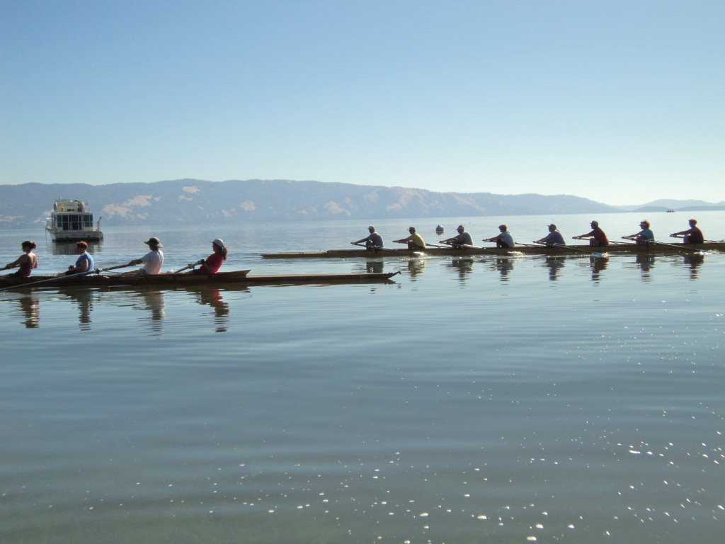
Adult membership is $100 for the summer, $200 for the full year, and includes sweep rowing camp and additional instruction in sculling and the use of a large array of club equipment, including rowing shells, surf skis, paddle boards, wind surfers and canoes. Adult sweep Rowing Camp will be sessions on June 27-29 and July 11-13, Fri, Sat Sun
Friday offers a choice of two sessions, 7-9 am or 5-7 pm.
Sat/Sun are sessions from 8 am to 10 am.
Our boat yard is in Lakeport at Main and 7th Street. Look for the boats down by the lake.

Check the website at www.clearlakescullers.org or contact Mike Sullivan at 707-349-9779 or sul@slac.stanford.edu for more information. ALSO:

Youth/HighSchool paddling/rowing/water safety camp: same weekends 10:00 – noon Fri-Sun.

